**UCS 2312 Data Structures Lab**

**Assignment 5: BSTADT and its application**

**Date of Assignment: 20.10.2023**

Create an ADT for the binary search tree data structure with the following functions. Each node which consists of integer data, address of left and right children. [CO2, K3]

1. insertBST(t,data) – insert data into BST
2. inorder(t) – display the tree using inorder traversal
3. preorder(t) – display the tree using preorder traversal
4. postorder(t) – display the tree using postorder traversal
5. levelorder(t) – display the tree hierarchically
6. findmin(t)– returns the minimum element in the tree
7. search(t,key) – returns the element found, otherwise returns NULL
8. delete(t,elt) – delete the given elt from tree

Write an application to do the following

* 1. Check whether the two BST contains the same set of elements
  2. Count the number of nodes in tree within the given range
  3. Find sum of k smallest elements in the given BST

**Data Structure – Binary Search Tree:**

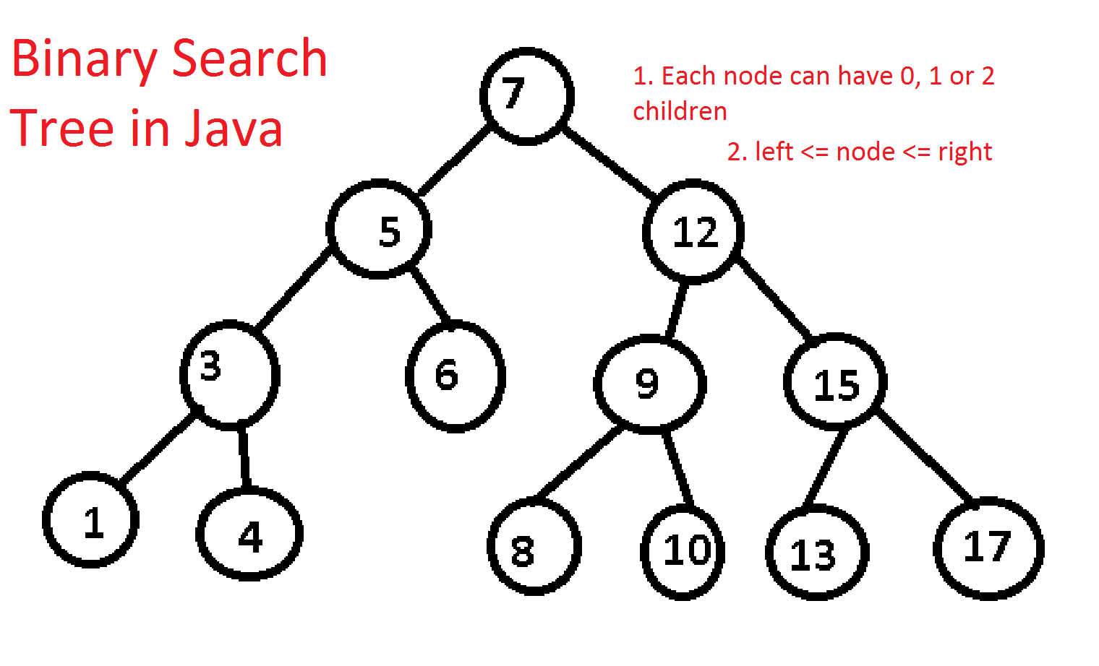

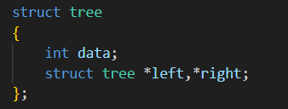

**Algorithm –**

**Algorithm: Insert data into BST**

Input – Pointer to tree, data to be added to tree

Output – struct tree *

1. if (t==NULL)

t=(struct tree *)malloc(sizeof(struct tree));

t->data=data;

t->right=NULL;

t->left=NULL;

1. if(data>t->data)

t->right=insert(t->right,data)

1. if(data<t->data)

t->left=insert(t->left,data)

1. return t

**Algorithm: Inorder**

Input – Pointer to tree

Output – void

1. if (t==NULL)

return

1. if(t->left!=NULL)

inorder(t->left)

1. print data in t
2. if(t->right!=NULL)

inorder(t->right)

**Algorithm: Preorder**

Input – Pointer to tree

Output – void

1. if (t==NULL)

return

1. print data in t
2. if(t->left!=NULL)

inorder(t->left)

1. if(t->right!=NULL)

inorder(t->right)

**Algorithm: Postorder**

Input – Pointer to tree

Output – void

1. if (t==NULL)

return

1. if(t->left!=NULL)

inorder(t->left)

1. if(t->right!=NULL)

inorder(t->right)

1. print data in t

**Algorithm: Levelorder**

Input – Pointer to tree, level of node

Output – void

1. if (t==NULL)

return

1. if(l==1)

print data in t

1. if(l>1)

level(t->left,l-1)

level(t->right,l-1)

**Algorithm: Returns the minimum element in the tree**

Input – Pointer to tree

Output – struct tree *

1. if (t->left==NULL)

return t

1. findmin(t->left)

**Algorithm: Returns the element found, otherwise returns NULL**

Input – Pointer to tree, data to be found

Output – struct tree *

1. if (t==NULL || t->data==key)

return t

1. if(key<t->data)

return search(t->left,key)

1. if(key>t->data)

return search(t->right,key)

**Algorithm: Delete the given elt from tree**

Input – Pointer to tree, data to be deleted

Output – struct tree *

1. if (data<t->data)

t->left=delete(t->left,data)

1. else if (data>t->data)

t->left=delete(t->right,data)

1. else if(t->left && t->right)

temp=findmin(t->right);

t->data=temp->data;

t->right=delete(t->right,temp->data);

1. else

temp=t;

if(t->right==NULL)

t=t->left;

else if(t->left==NULL)

t=t->right;

free(temp);

1. return t

**tree.h code:**

struct node

{

int data;

struct node * next;

};

void append(struct node* header,int data)

{

struct node* temp;

temp=(struct node *)malloc(sizeof(struct node));

temp->data=data;

struct node *ptr,*end;

ptr=header->next;

end=header;

while(ptr!=NULL)

{

end=ptr;

ptr=ptr->next;

}

temp->next=end->next;

end->next=temp;

}

struct tree

{

int data;

struct tree *left,*right;

};

struct tree * insert(struct tree *t, int data)

{

if(t==NULL)

{

t=(struct tree *)malloc(sizeof(struct tree));

t->data=data;

t->right=NULL;

t->left=NULL;

}

if(data>t->data)

{

t->right=insert(t->right,data);

}

if(data<t->data)

{

t->left=insert(t->left,data);

}

return t;

}

void inorder(struct tree *t)

{

if (t==NULL)

return;

if(t->left!=NULL)

{

inorder(t->left);

}

printf(" %d",t->data);

if(t->right!=NULL)

{

inorder(t->right);

}

}

void inorder1(struct tree *t,struct node *h)

{

if (t==NULL)

return;

if(t->left!=NULL)

{

inorder1(t->left,h);

}

append(h,t->data);

if(t->right!=NULL)

{

inorder1(t->right,h);

}

}

void postorder(struct tree *t)

{

if (t==NULL)

return;

if(t->left!=NULL)

{

postorder(t->left);

}

if(t->right!=NULL)

{

postorder(t->right);

}

printf(" %d",t->data);

}

void preorder(struct tree *t)

{

if (t==NULL)

return;

printf(" %d",t->data);

if(t->left!=NULL)

{

preorder(t->left);

}

if(t->right!=NULL)

{

preorder(t->right);

}

}

struct tree * findmin(struct tree *t)

{

if(t->left==NULL)

{

return t;

}

findmin(t->left);

}

struct tree * delete(struct tree *t,int data)

{

struct tree *temp;

if(data<t->data)

{

t->left=delete(t->left,data);

}

else if(data>t->data)

{

t->right=delete(t->right,data);

}

else if(t->left && t->right)

{

temp=findmin(t->right);

t->data=temp->data;

t->right=delete(t->right,temp->data);

}

else

{

temp=t;

if(t->right==NULL)

{

t=t->left;

}

else if(t->left==NULL)

{

t=t->right;

}

free(temp);

}

return t;

}

struct tree* search(struct tree* t, int key)

{

if(t==NULL || t->data==key)

return t;

if(key<t->data)

return search(t->left,key);

if(key>t->data)

return search(t->right,key);

}

int height(struct tree* t)

{

if (t == NULL)

return 0;

else

{

int lheight = height(t->left);

int rheight = height(t->right);

if (lheight > rheight)

return (lheight + 1);

else

return (rheight + 1);

}

}

void level (struct tree* t, int l)

{

if (t==NULL)

return;

if (l==1)

printf("%d ", t->data);

else if (l>1)

{

level(t->left, l-1);

level(t->right, l-1);

}

}

**tree.c code:**

#include<stdio.h>

#include<stdlib.h>

#include "tree.h"

void main()

{

struct tree *t=NULL,*s;

int choice =1,data,key;

while(choice)

{

printf("\n\n1.Insert\n2.Inorder\n3.Preorder\n4.Postorder\n5.Delete\n6.Search\n7.Level Order\n0.Exit\nChoice : ");

scanf("%d",&choice);

switch(choice)

{

case 1:

{

printf("Data = ");

scanf("%d",&data);

t=insert(t,data);

break;

}

case 2:

{

printf("Inorder t:");

inorder(t);

break;

}

case 3:

{

printf("Preorder t:");

preorder(t);

break;

}

case 4:

{

printf("Postorder t:");

postorder(t);

break;

}

case 5:

{

printf("Data to be deleted = ");

scanf("%d",&data);

t=delete(t,data);

break;

}

case 6:

{

printf ("Enter element to search: ");

scanf ("%d", &key);

s = search (t,key);

if (s==NULL)

printf ("Element not found.");

else

printf ("Element %d found.", s->data);

break;

}

case 7:

{

for (int i=0; i<=height (t); i++)

{

level(t,i);

printf("\n");

}

break;

}

default:printf("Invalid Choice");

}

}

}

**Output Screen:**

Insert(t,29)

Insert(t,23)

Insert(t,4)

Insert(t,13)

Insert(t,39)

Insert(t,31)

Insert(t,45)

Insert(t,56)

Insert(t,49)

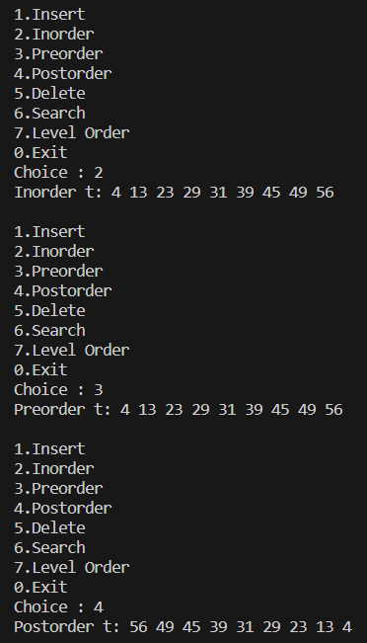

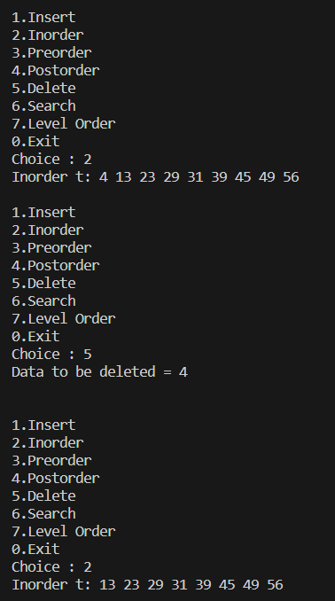

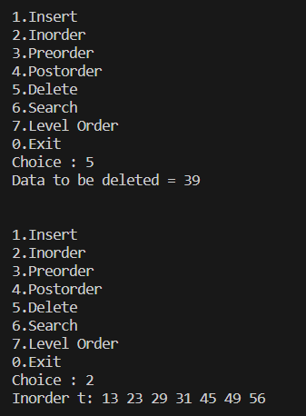

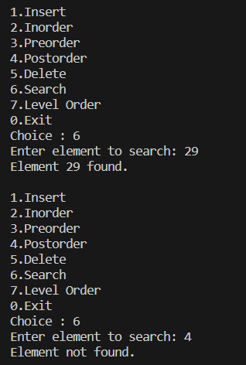

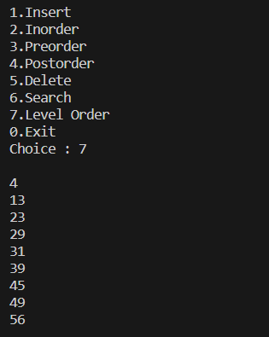

**APPLICATIONS:**

1. **Check whether the two BST contains the same set of elements**

**Code:**

#include<stdio.h>

#include<stdlib.h>

#include "tree.h"

int compare(struct tree *t1,struct tree *t2)

{

struct node *h1,*h2;

h1=(struct node *)malloc(sizeof(struct node));

h1->next=NULL;

h2=(struct node *)malloc(sizeof(struct node));

h2->next=NULL;

inorder1(t1,h1);

inorder1(t2,h2);

struct node *ptr1,*ptr2;

ptr1=h1->next;

ptr2=h2->next;

while(ptr1!=NULL && ptr2!=NULL)

{

if(ptr1->data!=ptr2->data)

return 0;

ptr1=ptr1->next;

ptr2=ptr2->next;

}

if(ptr1!=NULL || ptr2!=NULL)

return 0;

return 1;

}

void main()

{

struct tree *t1=NULL;

struct tree *t2=NULL;

int choice =1,data;

while(choice)

{

printf("\n\n1.Insert t1\n2.Insert t2\n3.Inorder\n4.Preorder\n5.Postorder\n6.Delete t1\n7.Delete t2\n8.Compare\n0.Exit\nChoice : ");

scanf("%d",&choice);

switch(choice)

{

case 1:

{

printf("Data = ");

scanf("%d",&data);

t1=insert(t1,data);

break;

}

case 2:

{

printf("Data = ");

scanf("%d",&data);

t2=insert(t2,data);

break;

}

case 3:

{

printf("Inorder t1:");

inorder(t1);

printf("\nInorder t2:");

inorder(t2);

break;

}

case 4:

{

printf("Preorder t1:");

preorder(t1);

printf("\nPreorder t2:");

preorder(t2);

break;

}

case 5:

{

printf("Postorder t1:");

postorder(t1);

printf("\nPostorder t2:");

postorder(t2);

break;

}

case 6:

{

printf("Data to be deleted = ");

scanf("%d",&data);

t1=delete(t1,data);

break;

}

case 7:

{

printf("Data to be deleted = ");

scanf("%d",&data);

t2=delete(t2,data);

break;

}

case 8:

{

if(compare(t1,t2))

printf("Same tree");

else

printf("Different tree");

break;

}

default:printf("Invalid Choice");

}

}

}

**Output:**

Tree1- insert(t,2), insert(t,1), insert(t,4), insert(t,6)

Tree2- insert(t,1), insert(t,2), insert(t,4), insert(t,6)

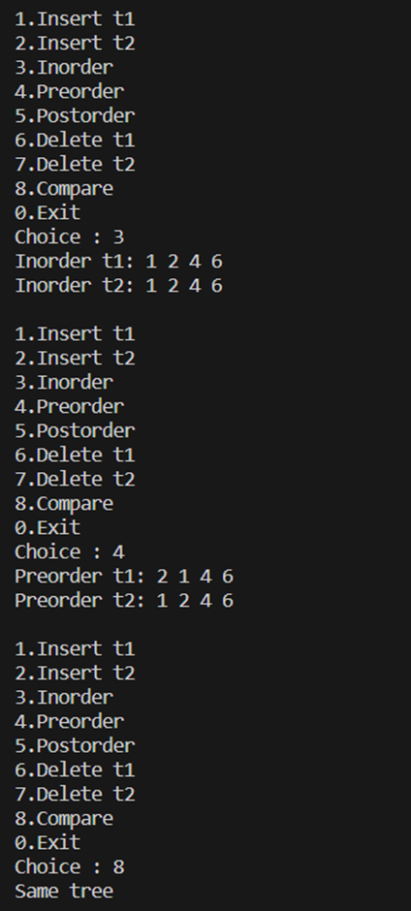

1. **Count the number of nodes in tree within the given range**

**Code:**

int count_nodes (struct tree* t, int start, int end, int c)

{

if (t->data>=start && t->data<=end)

c++;

else if (t==NULL)

return c;

else

{

if (t->left!=NULL)

count_nodes (t->left,start,end,c);

if (t->right!=NULL)

count_nodes (t->right,start,end,c);

}

}

**Output:**

Tree- insert(t,2), insert(t,4), insert(t,6), insert(t,1)

Range: 1-3



1. **Find sum of k smallest elements in the given BST**

**Code:**

int sum (struct tree* t, int k, int a[])

{

int sum=0;

array (t,a,0);

for (int i=0;i<k;i++)

sum+=a[i];

return sum;

}

**Output:**

Tree- insert(t,2), insert(t,4), insert(t,6), insert(t,1)

k=2



**Learning Outcome:**

